Third Party Visuals

D3 pie chart:

Usage : Digicom POC
URL : https://poc.anvizent.com
Dashboard : https://poc.anvizent.com/anvizent/mydb/view?ds=epicore&id=1&name=1

Purpose:
In google pie charts, the labels are not visible for very small values comapred with the larger values. It won't look good if some labels are visible and some are not visible. So we are going with d3 pie chart, where lables are visible outside/inside the pie chart area for the smallest value also. It is an open source.

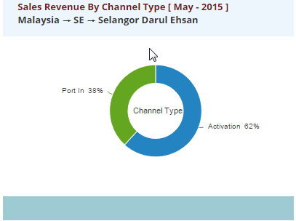

Customization:

- Coverting xml response to array and passing to the pie chart.
- Tooltip Customization to display $ prefix and percentage in brackets.
- Labels outside the chart area with percentages.
- Click events on pie segment to get the segment value.
- Segments colors.
- Adding effects (animation).

Telerik Kendo chart:

Usage : Digicom POC
URL : https://poc.anvizent.com
Dashboard : https://poc.anvizent.com/anvizent/mydb/view?ds=epicore&id=1&name=1
https://poc.anvizent.com/anvizent/mydb/view?ds=epicore&id=2&name=2
https://poc.anvizent.com/anvizent/mydb/view?ds=epicore&id=3&name=3

Purpose:
The scenario when we require to show the actual value versus target value then we can make use of kendo charts. In google charts we can show actual as a bar and target as a line but it will be a connecting line between the bars(i.e. time series). In kendo chart target will be just a line on top of the bar which is not connected with the next line. Its not a open source, we can get the trial version for 30 days.

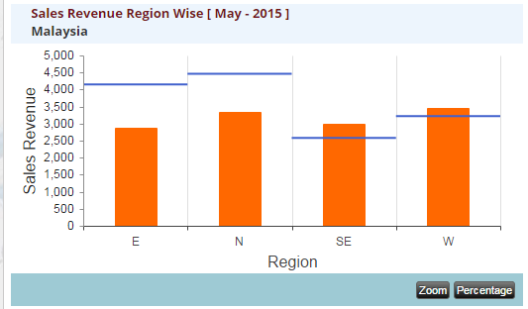

Percentage : Same kendo chart with only one series.
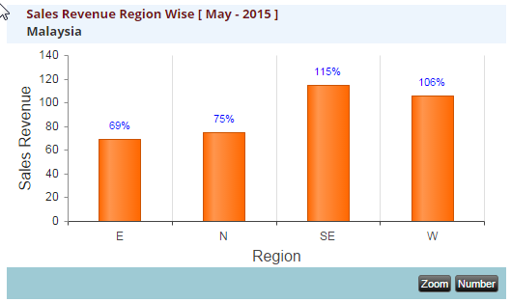

Customization:
- Coverting xml response to array and passing to the kendo chart.
- Tooltip position adjustments.
- Series colors.
- Click events ( plotAreaClick).
- Adjusting chart area
- Y-axis labels formatters.
- X-axis labels rotation and adjustments.
- Open dialog box on click of zoom button and draw the same kind of chart inside the dialog box with scroll bars.

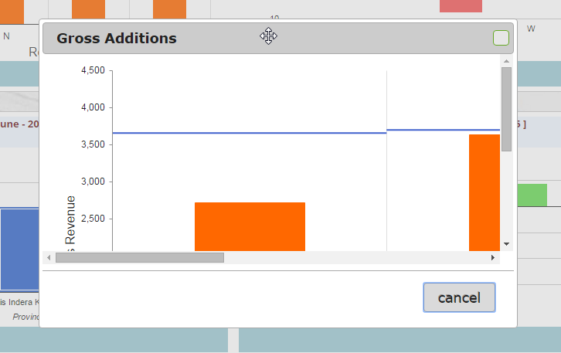

Comparision chart:
Usage : Digicom POC
URL : https://poc.anvizent.com
Dashboard : https://poc.anvizent.com/anvizent/mydb/view?ds=epicore&id=1&name=1
https://poc.anvizent.com/anvizent/mydb/view?ds=epicore&id=2&name=2
https://poc.anvizent.com/anvizent/mydb/view?ds=epicore&id=3&name=3

Purpose:
Whenever we want to show positive and negative values in the form of a bar, column or line chart, at that time we can go with this type of chart. It is a google column chart , which will take both positive and negative values and plot it accordingly.

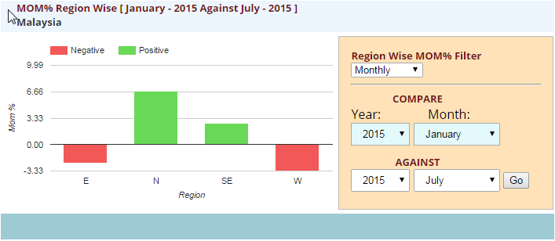

Customization:
- Coverting xml response to two arrays, one is based on compare 'year & month', and next is based on against 'year & month'. Then calculating the final result with the formula and passing the final array to the column chart .
- Giving comparision options as Monthly, Quartely, Half-Yearly and Yearly.

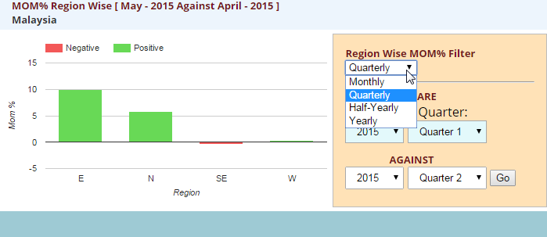
- Based on filter options the 'compare' and the 'against' filter's options will change.
Pie chart:
Usage : Thomas and Betts POC
URL : https://poc.anvizent.com
Dashboard : https://poc.anvizent.com/anvizent/mydb/view?ds=epicore&id=6&name=6
https://poc.anvizent.com/anvizent/mydb/view?ds=epicore&id=1&name=1

Purpose:
In google pie charts, the labels are not visible for very small values comapred with the larger values. It wont look good if some labels are visible and some are not visible. So we are customizing and writing the labels outside the chart.

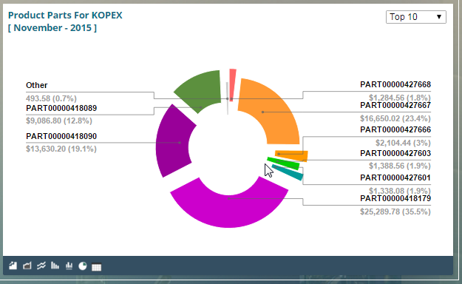

Customization:
- Making pie chart as 3D.
- Options: pieSliceText , pieHole , sliceVisibilityThreshold, reverseCategories,
- Adding slices

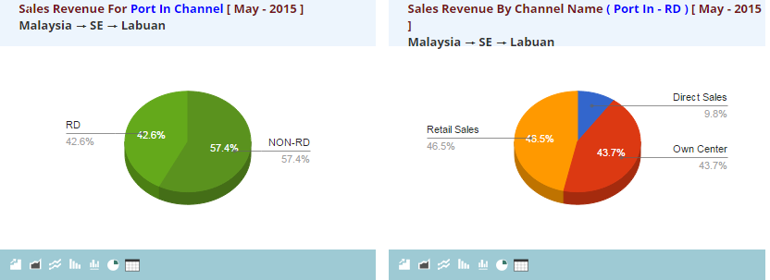

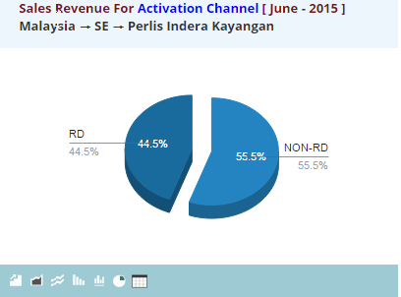

Tree Map:
Usage : Thomas and Betts POC
URL : https://poc.anvizent.com
Dashboard : https://poc.anvizent.com/anvizent/mydb/view?ds=epicore&id=6&name=6

Purpose:
It will plot different sized boxes based on the value (ex: sales, quantity) in descending order, so the first box will be of the largest value and by looking at it we can clearly understand the flow. So in the scenario when ever we want to show for which product the sales was heighest and for which the sales was lowest can be easily analysed by looking at the size of each box.

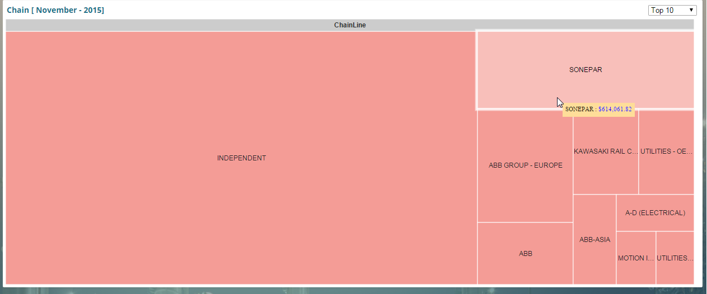

Customization:
- Added customized tooltip to the chart with number formatters.

HighChart's - Bullet :
Usage : Thomas and Betts POC (Future Orders)
URL : https://poc.anvizent.com
Dashboard : https://poc.anvizent.com/anvizent/mydb/view?ds=epicore&id=7&name=7

Purpose:
The scenario when we require to show the comparison of the featured measure to one or more related measures (for example, a target or the same measure at some point in the past, such as a year ago) and relate the featured measure to defined quantitative ranges that declare its qualitative state (for example, good, satisfactory, and poor). Its linear design not only gives it a small footprint, but also supports more efficient reading than radial meters.

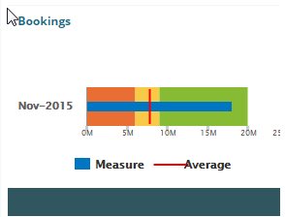

The bullet graph consists of five primary components:
- Text label
- A quantitative scale along a single linear axis
- The featured measure
- One or two comparative measures (optional)
- From two to five ranges along the quantitative scale to declare the featured measure’s qualitative state (optional)

Customization:
- Coverting xml response to array and passing to the kendo chart.
- Tooltip.
- Series colors.
- Y-axis labels formatters.
- X-axis labels rotation and adjustments.

Bar Chart-Annotation :
Usage : Thomas and Betts POC (Future Orders)
URL : https://poc.anvizent.com
Dashboard : https://poc.anvizent.com/anvizent/mydb/view?ds=epicore&id=7&name=7

Purpose : To show values as annotation

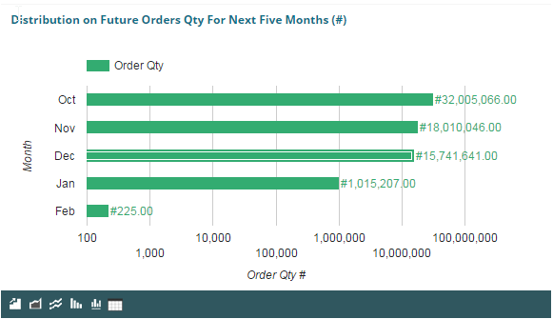

Customization:
- Adding annotation in ChartWrapper views options.
- Adding alwaysOutside: true, in vAxis .

GeoMap :

Usage : Technical Dashboard
URL : https://poc.anvizent.com
Dashboard Ids : https://poc.anvizent.com/anvizent/mydb/view?ds=epicore&id=11&name=11

Purpose : To add different types of markers to the map.

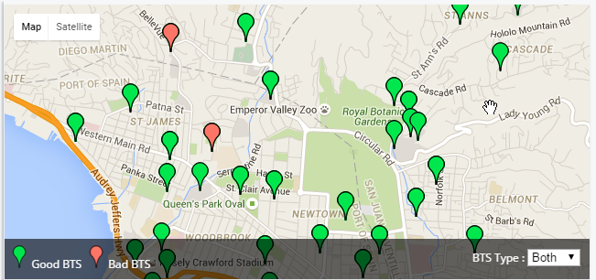
Customization:
- Added markers to the map.
- Markers will change based on the BTS type (good/bad).

Dual y-axis Combo Chart :

Usage : WC Injury OSHA - 1
URL : https://poc.anvizent.com
Dashboard : https://poc.anvizent.com/anvizent/mydb/view?ds=epicore&id=124&name=124

Purpose : To show two different series with two y-axis on the same chart.

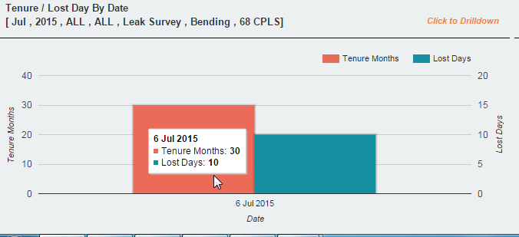
Customization:
- Adding v-axes instead of v-axis in the google combo chart.
Network Chart :
Usage : Oil and Gas
URL : https://poc.anvizent.com
Dashboard Ids : https://poc.anvizent.com/anvizent/mydb/view?ds=epicore&id=81&name=81

Purpose : To show network of connecting pipelines.

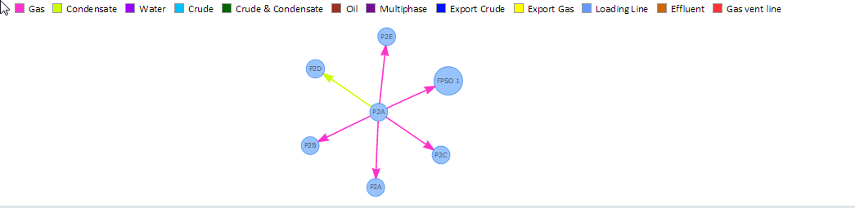
Customization:
- Coverting xml response to array and passing to the network chart.
- Adding static legends to the chart to show different pipeline type.
- Edge color based on type of pipeline.
- On mouse over of edge, tooltip will show pipeline information.
- Changing of node shape.

Rgraph Chart :

Usage : Oil and Gas POC
URL : https://poc.anvizent.com
Dashboard Ids : https://poc.anvizent.com/anvizent/mydb/view?ds=epicore&id=81&name=81

Purpose : Different visuals availabe other than google gauages ( semi gauge).
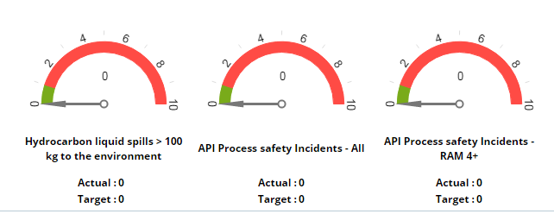

Customization:
- Adding the text related to each gauge.
- Adding customized color ranges based on the KPI.

Global Placeholders:

Usage : Digicom POC
URL : https://poc.anvizent.com
Dashboard : https://poc.anvizent.com/anvizent/mydb/view?ds=epicore&id=1&name=1
https://poc.anvizent.com/anvizent/mydb/view?ds=epicore&id=2&name=2
https://poc.anvizent.com/anvizent/mydb/view?ds=epicore&id=3&name=3

Purpose : To display the status (good/bad) as compared with the previous month/year values.

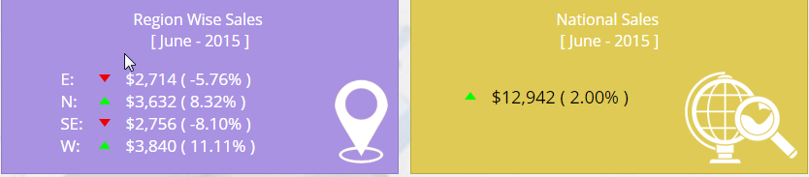

Customization:
Images will change based on the positive or negative values coming from backend.

Year And Month:

Usage : In almost all POCs till now
URL : https://poc.anvizent.com

Purpose:
In almost all the pocs that we have developed, we are externally adding filters for year and month selection using javascript.Because it depends on the data provided to us, whether it is only for one particular year-month or different year and months. According to that we need to add these filters in all pocs.

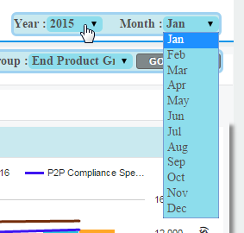

Customization:

- Add year and month drop downs in table td's with proper ids.(html)
- On change of drop down take the value of year and or month
and pass it to the respective chart using function call (script).
Data Filters , Go & Reset buttons:

Usage : Procurement
URL : http://hydpoc.dwpractice.com
Dashboard : http://hydpoc.dwpractice.com/anvizent/mydb/view?ds=epicore&id=68&name=68

Purpose:
The first level in the dashboard changes based on its above filters (on click of go button) as per the reqiurement.If we consider the filters which our tool can add in the dashboard, it is applicable only to the table level not the chart level although it will show in the particular chart. But that should be aplicable for both charts and table.

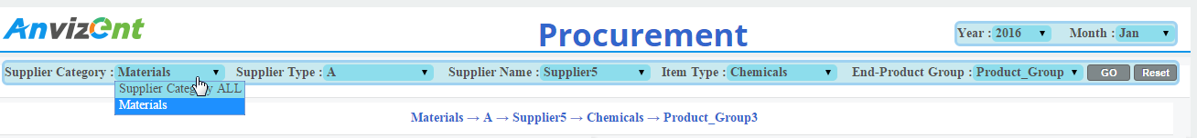

Customization:

- Add the required number of drop downs in table td's with proper ids given to it (html).
- On change of first drop down, take selected value and pass it to the function where second filter will change its content based on the provided value. Continue this process till the data which you want to pass to the charts (script).
- Click on go button will take all the filter values and call the chart function with the selected filter values.
- Reset button will change all the filters to its default values and the corresponding charts will also change.
Tabs:

Usage : MPS, MRP, SFC&Yield, Sales Booking
URL : http://hydpoc.dwpractice.com
Dashboard : http://hydpoc.dwpractice.com/anvizent/mydb/view?ds=epicore&id=89&name=89
http://hydpoc.dwpractice.com/anvizent/mydb/view?ds=epicore&id=145&name=145

Purpose:
Sometimes as per the requirment the dashboard length becomes too long such that we need to scroll down to reach to the last level (if there is no drill down). In that scenarios we have given tabs so that we can see different sections / levels of dashboard without much scrolling (MasterProductionSchedulenew.). Other than this we have given tabs so that the chart will change based on the value in the tabs (ytd/qtd/mtd etc in Revenue ).

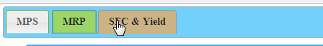

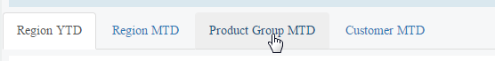

Customization:

- Added jquery tabs when we wanted to change the sections/levels of dashboard to eliminate more scrolling.(MasterProductionSchedulenew.)
- Added bootstrap nav-bar when we wanted to change only the charts based on the value of tab selected. Here we are taking the selected value from tab and calling the respective chart function to be displayed in the same container (here chart container wont change as in the jquery tabs).(Revenue ).
Year-Quarter-Month Filters:

Usage : Sales Booking
URL : http://hydpoc.dwpractice.com
Dashboard : http://hydpoc.dwpractice.com/anvizent/mydb/view?ds=epicore&id=145&name=145

Purpose:
In almost all the pocs that we have developed, we are externally adding filters for year and month selection using javascript.Here one extra filter i.e. Quarter. It was completly based on the yearly, quartely and monthly data provided to us. Charts will change based on the quartely and monthly data.

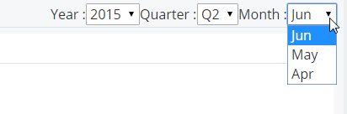

Customization:

- Added year, month and quarter drop downs in table td's with proper ids.(html)
- Based on quarter selected we are changing the months dropdown which comes in that quarter.(script)
- Based on the ids, taking the value of year, month and quarter and passing it in function so that the charts will change based on on change of year or month or quarter.(script)

Email :

Usage : Scorpio
URL : https://poc.anvizent.com
Dashboard : https://poc.anvizent.com/anvizent/mydb/view?ds=epicore&id=113&name=113

Purpose:
Email functionality is added as per the requirement, if we want to send image of the dashboard to a person.

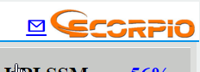

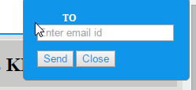

Customization:
- Added email icon with proper id(html).
- Created a form with one input text field to get email id and two buttons to send and close.
- On click of send it will call the screencapture servlet war file to capture the image and based on logic written in that file image of the dashboard will be sent to the provided email id.
Dashed line chart :

Usage : MPS, MRP, SFC & Yield
URL : http://hydpoc.dwpractice.com
Dashboard : http://hydpoc.dwpractice.com/anvizent/mydb/view?ds=epicore&id=89&name=89

Purpose:
The line chart which can be produced by using tool cannot give the dashed line feature, it can only give a continous line.It is the a useful feature which can be add in out tool in the same way as Line Point Shape, Line Point Size and Line Width so that people who want to see a dashed line can select type as dashed line and quickly generate the dashboard. It can be used in some scenarios when we want show comparision i.e. dashed line data campared with continous line data, in that cases we can go with dashed lines.

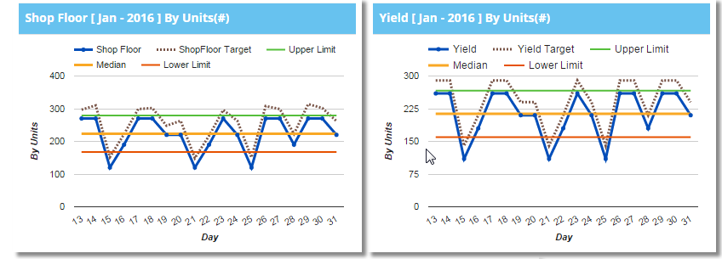

Customization:
- Added lineDashStyle[2,2] in the series option. Like this we have another type of dashed lines are also available
ex. lineDashStyle: [1, 1]
lineDashStyle: [2, 2]
lineDashStyle: [4, 4]
lineDashStyle: [5, 1, 3]
lineDashStyle: [4, 1]
lineDashStyle: [10, 2]
lineDashStyle: [14, 2, 7, 2]
lineDashStyle: [14, 2, 2, 7]
lineDashStyle: [2, 2, 20, 2, 20, 2]

Place Holders:

Usage : WC Injury OSHA-1
URL : https://poc.anvizent.com
Dashboard : https://poc.anvizent.com/anvizent/mydb/view?ds=epicore&id=124&name=124

Purpose:
Now a days, the common requirement is coming in most of the dashboard to display gloabal level data with small placehoders at the top of the dashboard (before any visuals starts). So we have added a small place holder at top right corner of this dashboard as per the requirememt which shows the summarized data. In that part we have added one filter as well so that user can select what summary he wants to see in that place, rather than adding four different place holders. So that it reduces the unnecessary space.

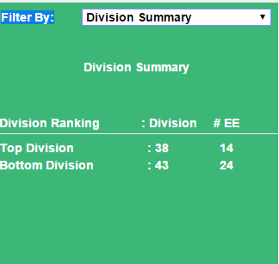
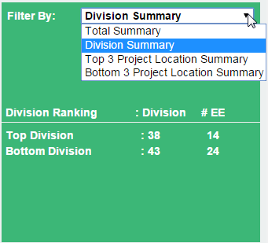

Customization:

- Added select & options fileds in the html part for the filter.
- Added three scripts for thee values in the filtes which contains ajax call, getting the values and appending that values to a spans with appropriate css.
- On change of filter, get the value and call the script.
Modify Data:

Usage : WC Injury OSHA-1
URL : https://poc.anvizent.com
Dashboard : https://poc.anvizent.com/anvizent/mydb/view?ds=epicore&id=124&name=124

Purpose:
As per the requirement, dashboard should show what data we want to see in the form of visuals. So a feature is added to this dashboard, by using which we can either add new data set in or we can append to the exsisting data.

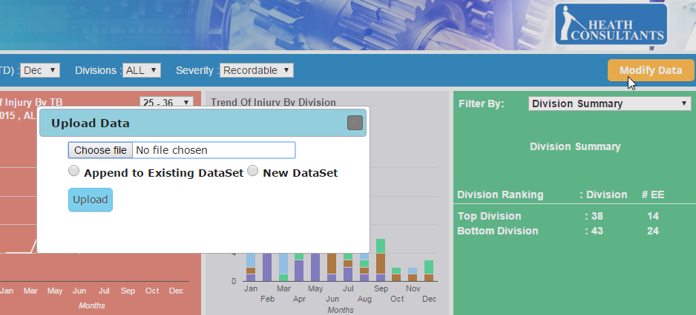

Customization:

- On click of modify button, it will open a dialog box.
- Append the excel file with proper template (same in design with the table design), with "choose file" input field .
- Select either Append to Existing DataSet or New DataSet radio button.
- On click of "Upload", it will call "uploadExcel" servet and executes its functionality.
Search:

Usage : Heath Report View
URL : https://poc.anvizent.com
Dashboard : https://poc.anvizent.com/anvizent/mydb/view?ds=epicore&id=129&name=129

Purpose:
As per the requirement, when we don't want to see complete data, instead we want to search/filter data, at that point search option can help. So a search option was added in this dashboard, which have different search options. Also to go back to the home page(i.e. WC Injury OSHA-3 Dashboard ) we have given one button as "Back". And to reset all the search boxes a "Reset" button is added.

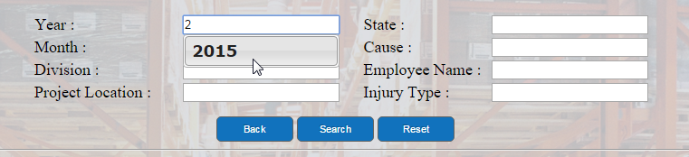

Customization:
- Added the required input text boxes in html part with three buttonss as Back, Search and Reset.
- Wrote code for autocomplete for all the text boxes.
- On click of search button it will collect all text box value in variables and query will be fired and related data will populate in the Tabular format.

Freight Cost Button:

Usage : Logistic Management
URL : http://hydpoc.dwpractice.com
Dashboard : http://hydpoc.dwpractice.com/anvizent/mydb/view?ds=epicore&id=129&name=129

Purpose:
As per the requirement, when we click on this button it will show a filter with four options. On change of any option, it will draw the particular chart. Then on click of Logistic cost button another chart will draw, and this filter will hide.

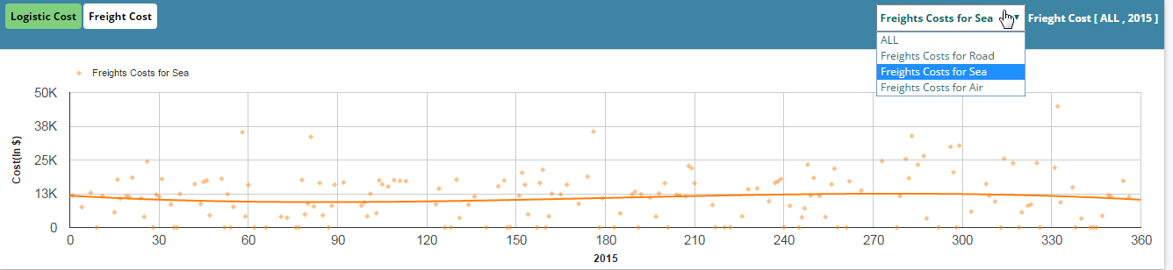
Customization:
- Added buttons and drop down fields in the html part.
- On change of drop down, based on the selection it will call a script and draw the chart.
Filetrs and Search document:

Usage : Oil And Gas
URL : https://poc.anvizent.com
Dashboard Ids : https://poc.anvizent.com/anvizent/mydb/view?ds=epicore&id=81&name=81

Purpose:
As per the requirement, on change of one filter (Discipline Name) data will be populated in next filter which is related to the above filter selected value. This process continues till fourth filter and on change of fifth filter it will open pdf document in new window.
And in case of "Technical Standards", on click of search icon, it will open a new window which conatins a table with data related to selected value in the dropdown. In that table data will populate as hyperlinks and on click of any of those links, it will open a pdf document in same window.

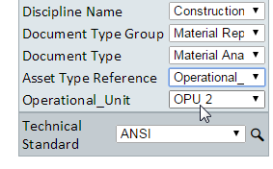

Customization:
- Added dropdowns and a search icon in html part.
- Fiter on change will call methods(ajax) of next filter to populate its data.
- Open window function which contains location of the given pdf.
- Google table customization to add hyperlinks for the exsisting data.
Selection Filters In Dialog Box:

Usage : Oil And Gas
URL : http://hydpoc.dwpractice.com
Dashboard : http://hydpoc.dwpractice.com/anvizent/mydb/view?ds=epicore&id=152&name=152

Purpose:
As per the requirement, on click of button showing an popup window is a good option. It can help up when we want to move to some another dashboard or when we want to open a docuemnt from the existing dashboard, after proper filter selections.

Customization:

- On click of "Document Management System" button, opening a popup window (dialog box).

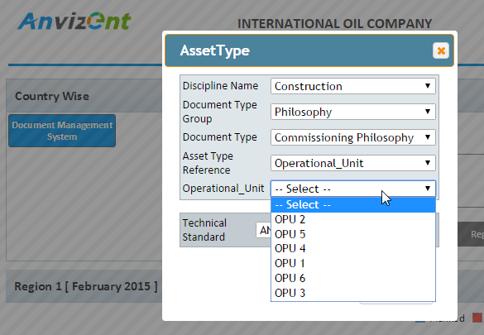

- Inside it, we are placing filters as part of the html code and script.

- On selection of proper values in the last filter ("Operational_Unit" in above image ),it opens related pdf document.
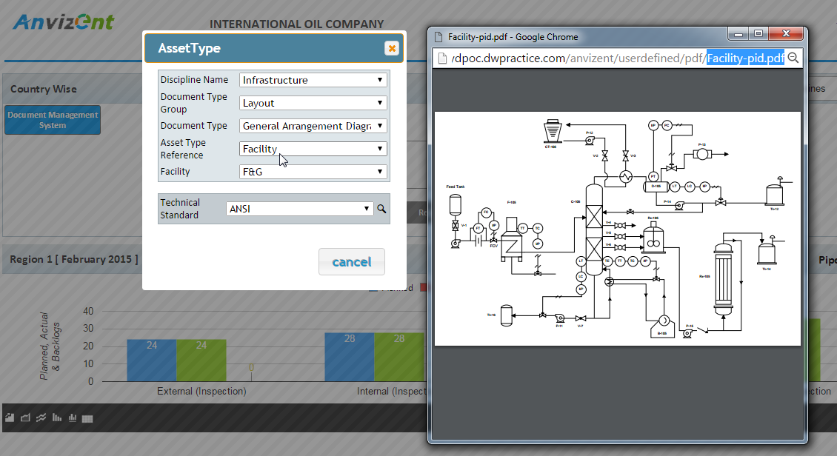
- There is one more filter available i.e. "Technical Standards", which shows three options (ANSI, API & ASME).
- On selection of any of those and clicking on the search icon, it will open another window and will populate data related with selected value in tabular form.

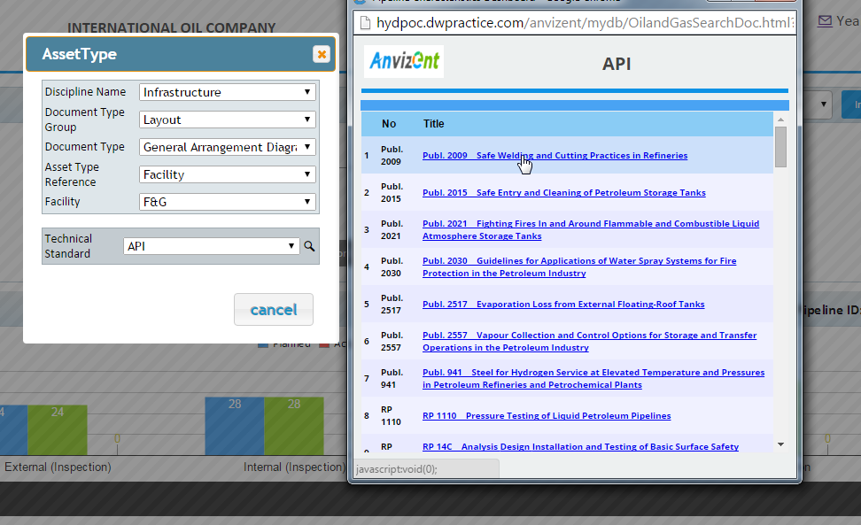
- The data in the table contains hyperlinks, on click of any hyperlink it will open related document.
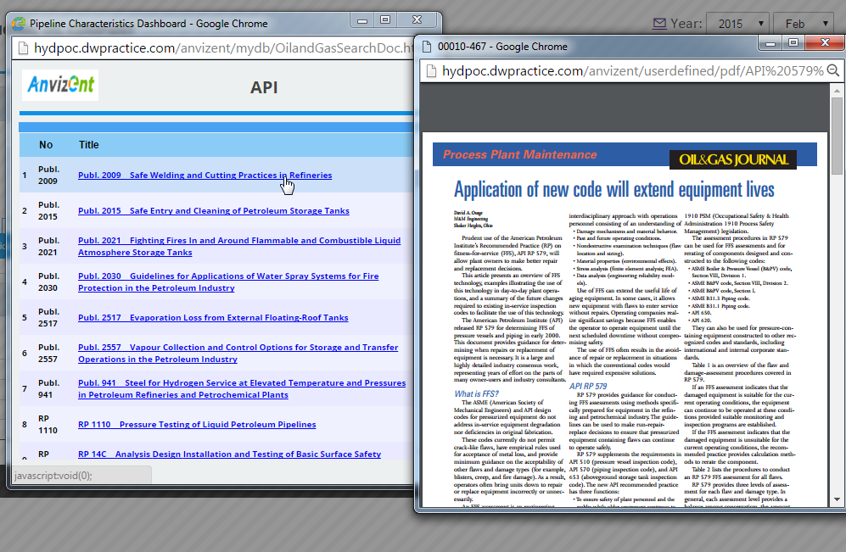
Search Box:

Usage : Health Care
URL : http://hydpoc.dwpractice.com
Dashboard : http://hydpoc.dwpractice.com/anvizent/mydb/view?ds=epicore&id=190&name=190
http://hydpoc.dwpractice.com/anvizent/mydb/view?ds=epicore&id=191&name=191

Purpose:
On click of search icon/button chart should display only searched information. Whenever user knows what data he wants to see in the chart, he can search in the text box, and click on the search icon to see the results.



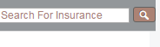

Customization:

- Added input text box and a search icon with proper Ids, as a part of html.
- To fill the Doctors/Hospitals/Insurance list, ajax with autocomplete functionality.
- On click of search icon, calling the chart draw function to show the related information.
Top Level Buttons:

Usage : Scorpio
URL : https://poc.anvizent.com
Dashboard : https://poc.anvizent.com/anvizent/mydb/view?ds=epicore&id=122&name=122

Purpose:
Added the top level static buttons as per the requirement, so that the dashboard will change based on the selection. Its a good option other than tabs. The text color of the buttons will change based on overall summary. If overall summary is upto the mark or more than that, then it appears in green color, or else it appears in red color.
Added spans as Fleet and Year filter dynamically from the data coming from backend which looks like buttons. On click of it changing the charts data. Color of the spans also changes based on the click event, so that it should look like it is selected.
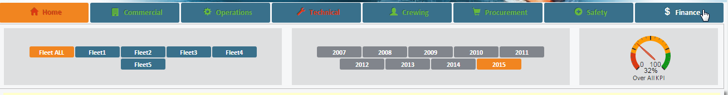

Customization:
- Added 8 static buttons with proper Ids as a part of html.
- As a part of script, written on click event for required buttons.
- Based on the overall summary data coming from backend, changing the text color of each button using if/else conditions.
- When data is coming from backend for "Fleets " and "Years", appending it as spans in respective div Ids.
- On click of any span, adding class to add different background color(to show it as selected) and removing class from all its neighbouring spans to give similar background color(to s unselect all others).
Bar Format In Table:

Usage : Scorpio
URL : https://poc.anvizent.com
Dashboard : https://poc.anvizent.com/anvizent/mydb/view?ds=epicore&id=122&name=122

Purpose:
Bar format is a good visual when we dont want to see direclty numerical values in the table, but a bar beside the numerical value. The bar takes its length as maximum number in the column, and we can just predict by looking at it, that how much this value is less than the maximum value.

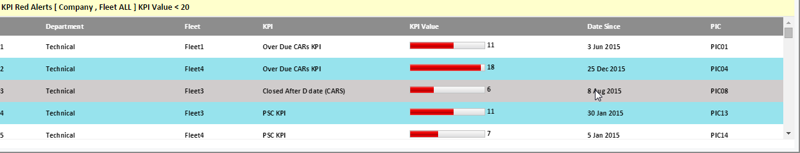

Customization:
- Added Bar Format property in google chart formatter.
- Added width and red color in its parameters.
Organisation Chart

Usage : Scorpio
URL : https://poc.anvizent.com
Dashboard : https://poc.anvizent.com/anvizent/mydb/view?ds=epicore&id=122&name=122

Purpose:
Each node in the organisation chart will have one name, so based on the name/value we can change color of the node using "setRowProperty".
On click event on node of org chart, giving window.open option which opens the Scorpio dashboard.(Except the root node).

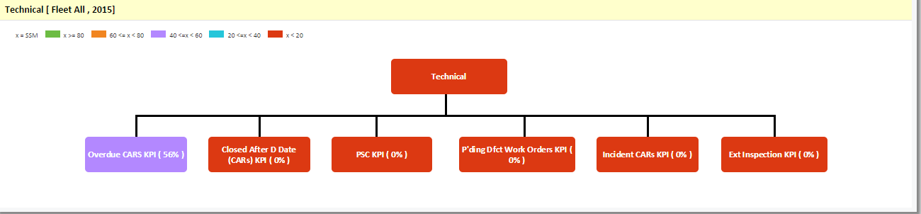

Customization:

- In the script, given background color to each node of Org Chart based on if/else condition, depending on the backend value for each node.
- Window.open option on click event for each node except the root node.

